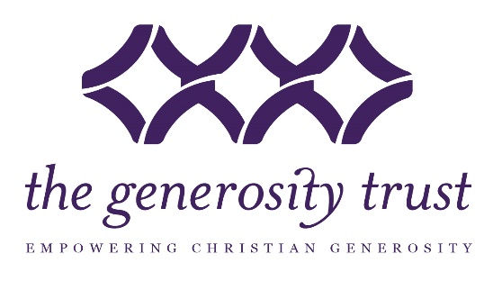

Young Givers 2021 Schedule

First Quarter 2021
Lunch & Learn January 14 (Thurs., Noon to 1 pm-Zoom)
Grant Application Deadline January 25 (Monday)
Giving Circle Meeting February 25 (Thursday. Noon to 1:00 pm-Zoom)
Lunch & Learn March 18 (Thur., Noon to 1 pm-Zoom)

Second Quarter 2021
Grant Application Deadline May 3 (Monday)
Giving Circle Meeting May 27 (Thurs., Noon to 1 pm)
Lunch & Learn June 17 (Thurs., Noon to 1 pm)

Third Quarter 2021
Grant Application Deadline August 2 (Monday)
Giving Circle Meeting August 27 (Thurs., Noon to 1 pm)
Lunch & Learn September 16 (Thurs., Noon to 1 pm)

Fourth Quarter 2021
Grant Application Deadline November 1 (Monday)
Giving Circle Meeting December 2 (Thurs., Noon to 1 )
Lunch & Learn January 13, 2022 (Thurs., Noon to 1 pm)

